Homework 2
1.
(1) A base current of 50 μA is applied to the transistor in Figure 1, and a voltage of 5 V is dropped across R_{C}. Determine the β_{DC} of the transistor ..
(2) Assume that the transistor in the circuit of Figure 1 is replaced with one having a β_{DC} of 200. Determine I_{B}, I_{C}, I_{E}, and V_{CE} given that V_{CC} = 10 V and V_{BB} = 3 V.
(3) If V_{CC} is increased to 15 V in Figure 1, how much do the currents and V_{CE} change?

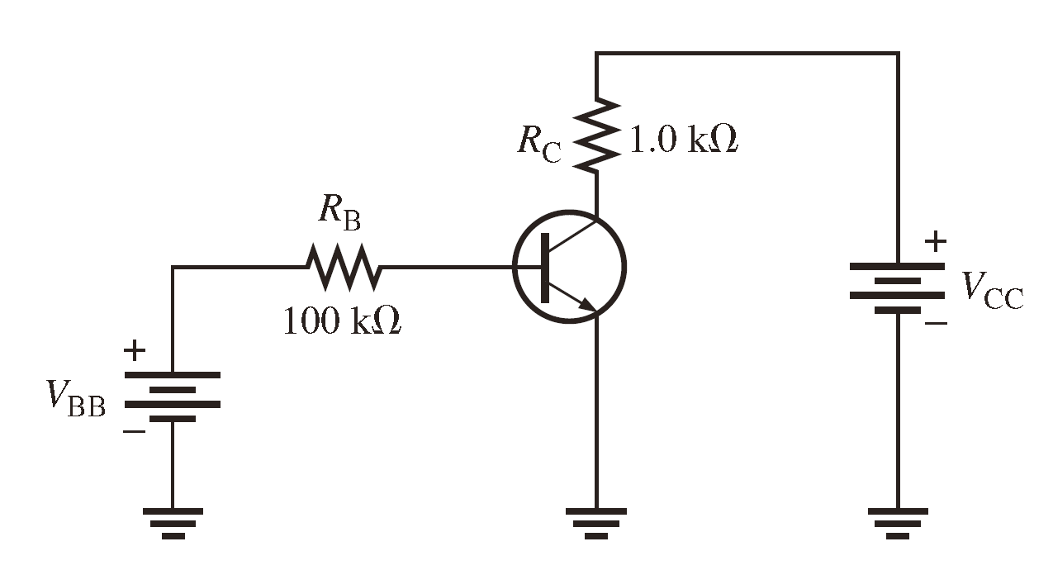
Figure. 1

2.
Find V_{CE}, V_{BE}, and V_{CB} in circuits of Figure 2.
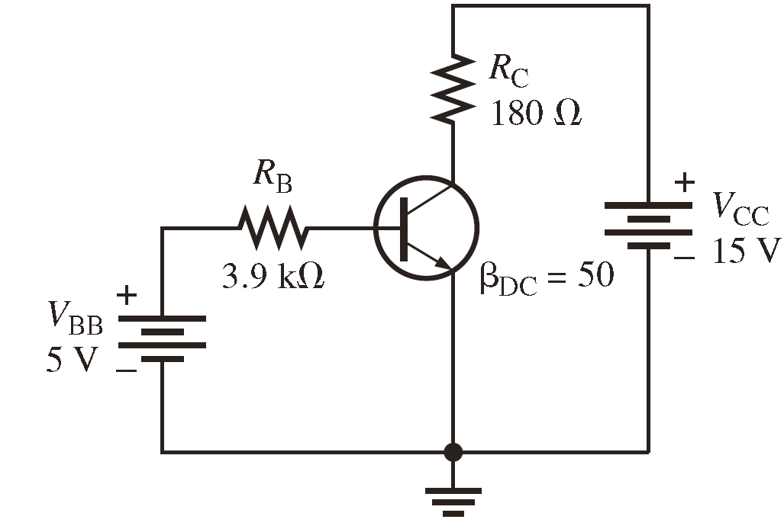
Figure. 2

3.
Determine the terminal voltages of each transistor with respect to ground for circuit in
Figure 3. Also determine VCE, VBE, and VCB.
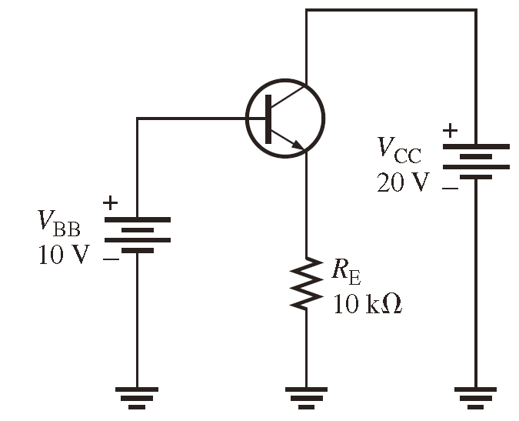
Figure. 3
4.
Assume that you wish to bias the transistor in Figure 4 with IB = 20 μA. To what voltage must you change the VBB supply? What are IC and VCE at the Q-point, given that β_{DC} = 50?
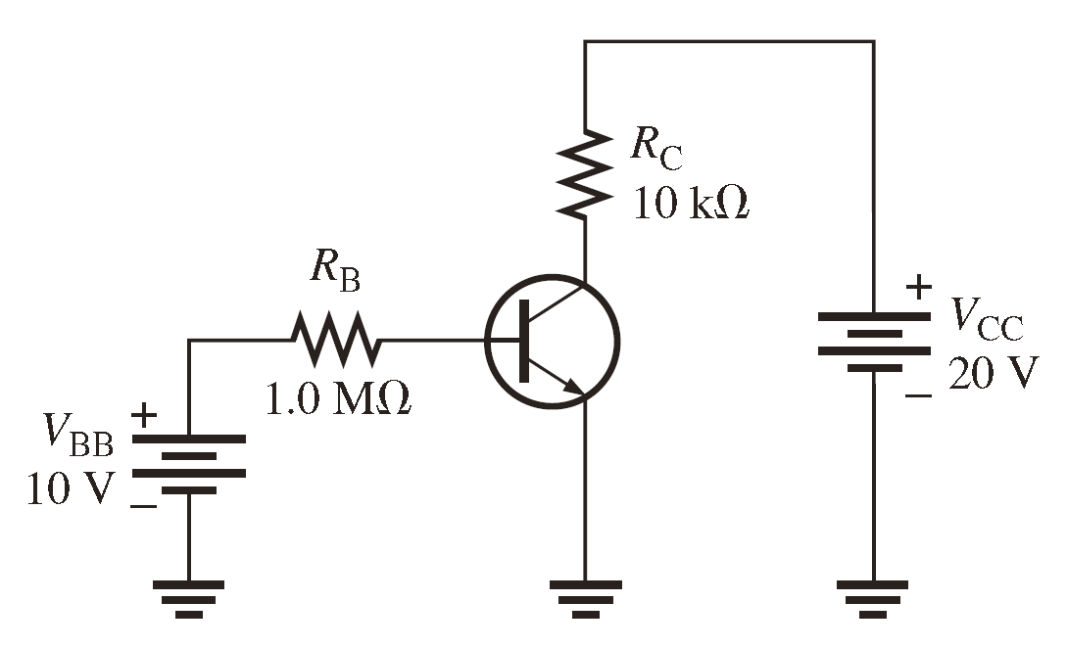
Figure. 4

5.
(1) Determine all transistor terminal voltages with respect to ground in Figure 5.
(2) The bias resistor R2 in Figure 5 is replaced by a 15 kΩ potentiometer. What minimum resistance setting causes saturation? (Assuming V_{BE}=V_{CE} when saturation happens)
(3) If the potentiometer described in Problem (2) is set at 2 kΩ, what are the values for IC and VCE?
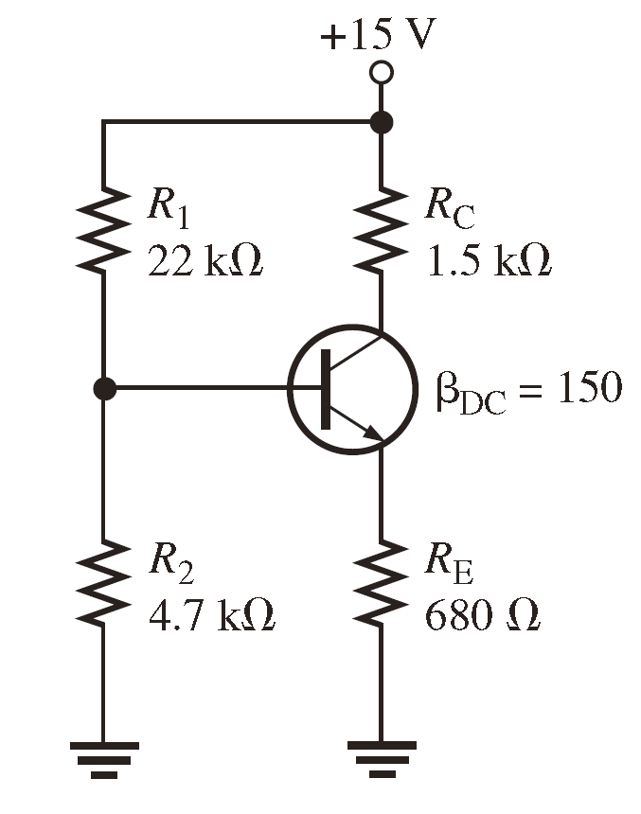
Figure. 5

6.
- Analyze the circuit in Figure 6 to determine the correct voltages at the transistor terminals with respect to ground. Assume βDC = 100.
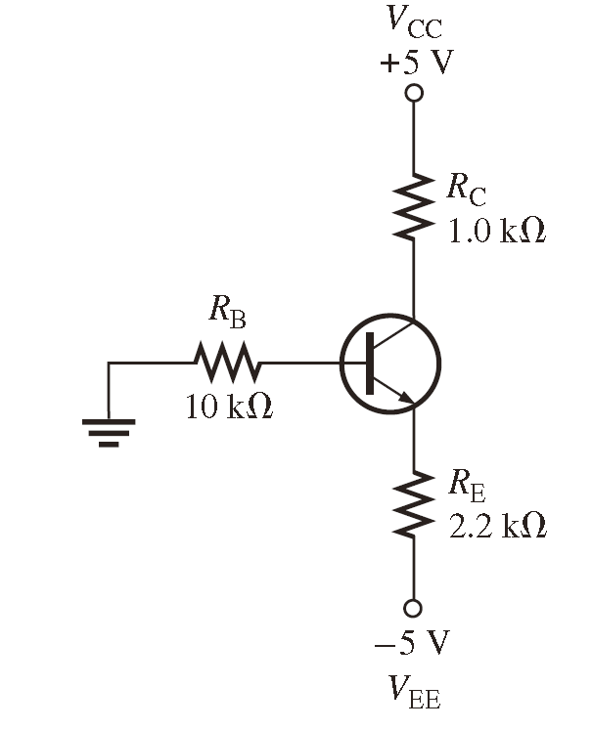
Figure. 6

7.
Determine VB, VC, and IC in Figure 7.

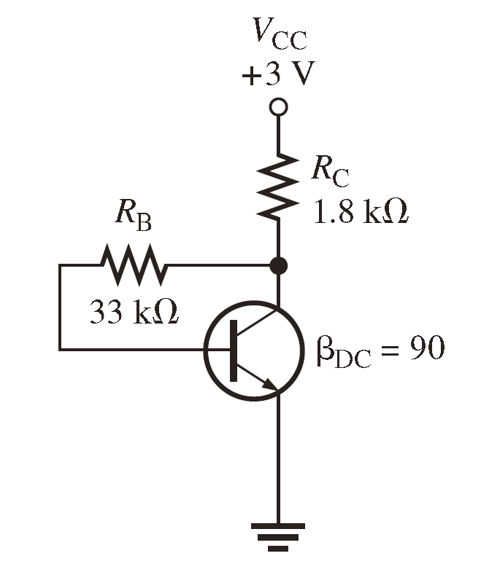
Figure. 7

8.
(1) Draw the dc equivalent circuit and the ac equivalent circuit for the unloaded amplifier in Figure 8. ( In the ac equivalent circuit, the transistor should also use AC model)
(2) Determine the following dc values for the amplifier in Figure 8.
(a) VB (b) VE (c) IE (d) IC (e) VC
(3) Determine the following values for the amplifier in Figure 8.
- Rin(base) (b) Rin(tot) (c) Av
(4) Connect a bypass capacitor across RE in Figure 8, and repeat Problem (3).
(5) Connect a 10 kΩ load resistor to the output in Figure 8, and repeat Problem (4).
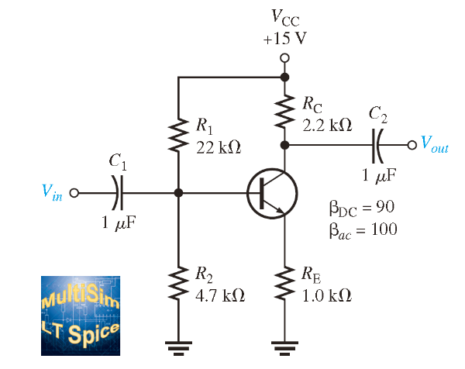
Figure. 8

9.
(1) Determine the exact voltage gain for the unloaded emitter-follower in Figure 9.
(2) What is the total input resistance in Figure 9? What is the dc output voltage?
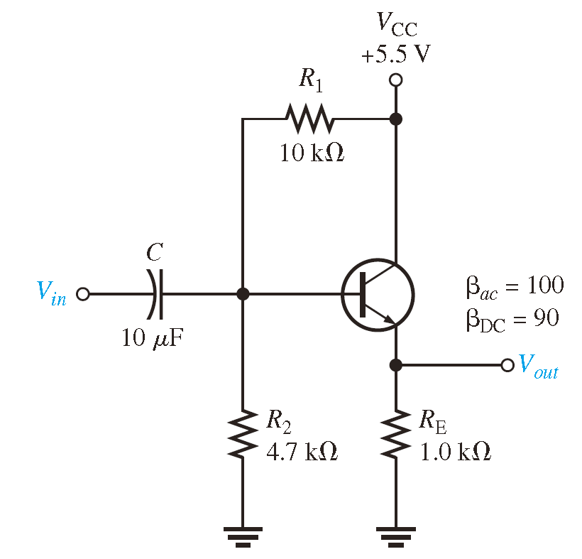
Figure. 9

